## Computer Networks 1

**Lab 1**

Network Devices

# Objectives:

Student Name:................Lê Bảo Khánh...................................

Student No.:......... ...............1911363......................................

* Get to know basic network devices
* Understand functions of network devices
* Able to connect different network devices together to form a simple network

# Content

## Get to know network devices:

* + Network Interface Card (NIC)
  + Cables
  + Hub
  + Switches
  + Routers
  + Access Points
  + Modems

## Understanding functions of network devices

### Network Interface Card (NIC)

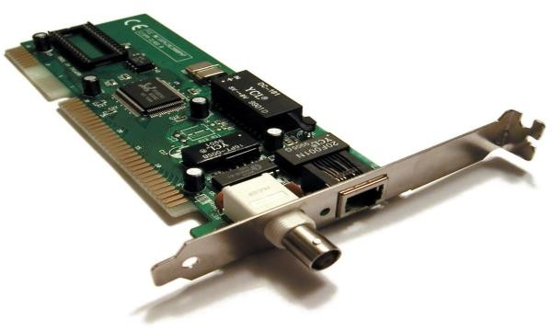

NIC functions: connects a computer to a computer network Code of NIC processors: PCI\VEN10EC&DEV8168&SUBSYS08441028&REV15\01000000684CE00000 Check NIC of a computer, what is its MAC address? 6C-2B-59-57-47-C0

Cable to connect NIC to a network:

Type: Coaxial cabling, Twisted-pair cabling, Fiber-optic cabling

Standard: Cat 3, Cat 5, Cat 5e, Cat 6, Cat 6a, Cat 7, Cat 8

### Hubs

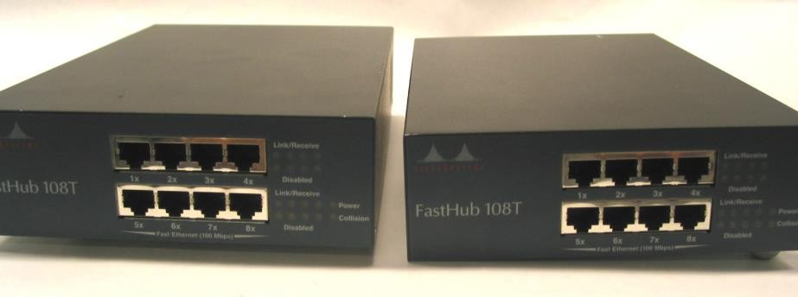

Roles of hub in a network: central connection point for Local Area Network (LAN)

Main characteristics:

+ Hub is a basic (dumb device) and does not need an IP address

+ Half-duplex: When a hub receives a packet of data (an Ethernet frame) at one of its ports from a network device, it transmits (repeats) the packet to all of its ports to all of the other network devices

+ Limited capabilities and poor scalability

+ Lower prices than switches

Weaknesses of hub: security risk, bottlenecks

Hub ports: 4 to 12 ports

### Switches

Roles of switches in a network: central connection point for Local Area Network (LAN)

Main characteristics:

+ Switches are “Intelligent devices”

+ When the data packet arrives, it reads the destination address and sends it to the appropriate system

Differences between hubs and switches:

|  |  |  |
| --- | --- | --- |
| Feature | Hubs | Switches |
| Device type | * “Dumb devices” * Passive devices, without associated software | * “Intelligent devices” * Active devices, equipped with network software |
| Functions | Can connect multiple Ethernet devices as a single segment | Can join multiple devices within one LAN |
| Data Transmission Form | Electrical signal or bits | Frame and packet |
| Transmission Mode | Half-duplex | Half/full-duplex |
| Address Used for Data Transmission | Use frame flooding  (not use MAC address) | MAC address |
| Operation | Broadcast all incoming packet data indiscriminately to every single computer connected to them | * Reads the destination address and sends it to the appropriate system rather than sending it to all connected devices. * If the destination address is not available, the switch sends the data packet to all the devices across the network |
| Layer (OSI model) | Physical layer (layer 1) | Data link layer (layer 2) |
| Efficient | Worse | Better |
| Price | Cheaper | More expensive |
| Collision | When more than one computers place data simultaneously in the corresponding ports | Not occur |
| Security | Risky | Safer |
| Popularity | Less common | More common |

Weaknesses of switches: more expensive

Switch ports: 24 - 48 ports

### Routers

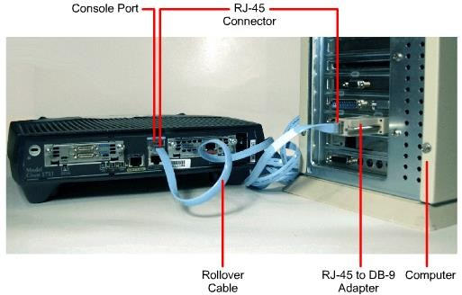

Roles of routers in a network: central connection point for Local Area Network (LAN)

Main characteristics of routers:

+ Most intelligent device: It is designed to understand, manipulate, and direct data packets based on their IP addresses

+ When a data packet is received, it inspects the IP address and determines if the packet was meant for its network or not. If yes, then it receives the data packet, and if not then it sends it off to another network.

Differences between routers and switches:

|  |  |  |
| --- | --- | --- |
| Feature | Routers | Switches |
| Device type | “Most intelligent” | “Intelligent devices” |
| Functions | Can use in LANs, MANS, WANs, | Can join multiple devices within one LAN |
| Data Transmission Form | Packet | * Frame (L2 switch) * Frame + Packet (L3 switch) |
| Transmission Mode | Full-duplex | Half/full-duplex |
| Address Used for Data Transmission | IP address | MAC address |
| When a data packet is received | Inspects the IP address and determines if the packet was meant for its network or not:  - If yes, then it receives the data packet  - If not, then it sends it off to another network. | * Reads the destination address and sends it to the appropriate system rather than sending it to all connected devices. * If the destination address is not available, the switch sends the data packet to all the devices across the network. |
| Layer | Network layer (layer 3) | Data link layer (layer 2) |
| Broadcast domain | 1 broadcast domain / 1 port | Only 1 |
| Connection type | Wired + Wireless | Wired |
| Connection time | More time (with complicated routing decision) | Faster routing decision |

Router ports: 2/4/8 ports

### d. Access Points

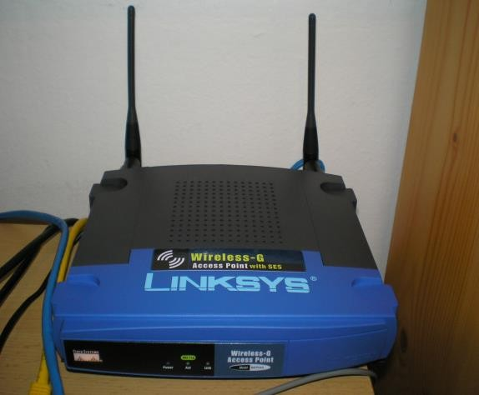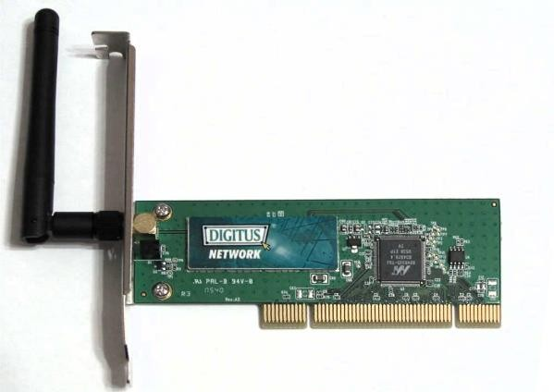

Roles of access points: allows other Wi-Fi devices to connect to a wired network

Main characteristics of access points:

+ Wireless connectivity is typically the only available option for access points, establishing links with end-devices using Wi-Fi.

+ Wireless access points are in fact radio transmitters and represent a node, just like a computer, on a local area network (LAN)

+ A wireless client associates with a wireless network by connecting to the access point and providing the required encryption data if necessary

+ Access points offer a standard for connectivity – a, b/g, b/g/n which are all ratified by IEEE so that the Wi-Fi systems from various vendors can connect to the network.

+ Access points connect to PC’s, laptops, PDA’s, mobiles, Wi-Fi phones, Wi-Fi Cameras, Wi-Fi display management systems and a host of other devices that work on the Wi-Fi standard.

+ Access points can also scan the network for wireless threats and attacks.

Access point’s interfaces:

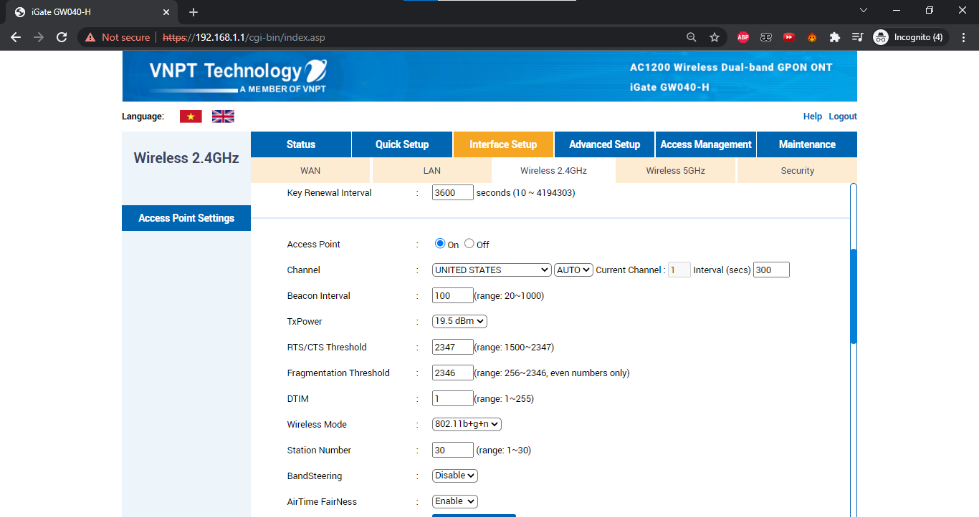

Compare access point and other networking devices mentioned above:

|  |  |  |  |
| --- | --- | --- | --- |
| Hubs | Switches | Routers | Access Point |
| Hubs are used to connect computers on a network so as to communicate with each other. Each computer plugs into the hub with a cable, and information sent from one computer to another passes through the hub. | Switches functions the same way as hubs, but they can identify the intended destination of the information that they receive, so they send that information to only the computers that its intended for. | Routers are better known as intermediary devices that enable computers and other network components to communicate or pass information between two networks e.g. between your home network and the Internet. | Access points provide wireless access to a wired Ethernet network. An access point plugs into a hub, switch, or wired router and sends out wireless signals. This enables computers and devices to connect to a wired network wirelessly. |
| A hub can’t identify the source or destination of the information it receives, so it sends the information to all of the computers connected to it, including the one that sent it. A hub can send or receive information, but it can’t do both at the same time. | Switches can send and receive information at the same time, and faster than hubs can. Switches are best recommended on a home or office network where you have more computers and want to use the network for activities that require passing a lot of information between computers. | The most astounding thing about routers is their capability to direct network traffic. Routers can be wired (using cables) or wireless. Routers also typically provide built-in security, such as a firewall. | You can move from one location to another and continue to have wireless access to a network. When you connect to the Internet using a public wireless network in an airport, hotel or in public, you are usually connecting through an access point. Some routers are equipped with a wireless access point capability, in this case you don’t need a wireless access Point. |

### e. Modem

Differentiate:

* Dial-up Modem
* ADSL Modem
* Cable Modem

For each type of modem describe its roles and characteristics:

|  |  |  |  |
| --- | --- | --- | --- |
|  | Dial-up Modem | ADSL Modem | Cable Modem |
| Role | + Dial-up modem is a communications device that can convert digital signals to analog signals and analog signals to digital signals, so that data can travel along an analog telephone line  + Dial-up modems are used to transfer the data on a daily basis from various locations of the organization to the NOC center. They are time-effective and cheaper to use for this purpose. It is also used in taking regular backup of data from the devices | + ADSL is a popular digital line alternative for the small business or home user. ADSL is ideal for Internet access.  + ADSL is usually used in places that have low data requirements like watching videos, downloading movies etc. | + Cable modem is a digital modem that sends and receives digital data over the cable television (CATV) network  + Cable modem is used in large scale data usage like in business or companies. This is also used for gaming. |
| Characteristics | + This is the grandpappy of internet connections and just as slow… like, S-L-O-W, capable only of 56kbps or lower. However, for the most basic uses such as sending mails with small- to medium-sized files attached, dial-up should do.  + Dial-up will also allow you to view most websites, generally content-heavy ones. But sites loaded with graphics, animations and other tricks will take a while to load. For real-time viewing and videos, dial-ups can’t perform as well. The connection will also hog the phone line so making or receiving phone calls when internet access is on can only be done using a separate line. | + ADSL stands for Asymmetric Digital Subscriber Line. It is a type of broadband connection and considerably much faster than dial-up. ADSL is a type of DSL.  + ADSL connection will not tie up a phone line. It’s always available so there is no need to dial an ISP. ADSL speeds can go from several hundred kbps to around 8 Mbps. This much speed allows high volume data use, loads websites quickly and is quite efficient to use with live chats, viewing videos in real time and playing online games. | + Cable internet connection is faster than a dial-up but sometimes slower than ADSL. Internet connection is obtained using a cable modem. This connection will be shared on lines used for cable TV. To transmit data, space reserved for TV channels are used, some to handle upstream transmissions and others for downstream transmissions. |

## Connecting network devices:

**Identify the type of network cable can be used for below network connections:**

1. Computer and hub straight-through
2. Computer and switch straight-through
3. Computer and router crossover

1. Computer hub and hub crossover
2. Hub and switch crossover
3. Hub and router straight-through
4. Switch and switch crossover
5. Swith and router straight-through

k) Router and router crossover